Z-Transform and Inverse Z-Transform

ECE 340 Lab D51
Riley Dixon - 1425251
Lab performed: November 10th, 2017

Analytic Solutions:
Lab3A Answers:
Based on the figure generated of both the input impulse and output response the system appears to be unstable as it is exponentially decreasing towards negative infinity. The z-transform can be obtained by first using the z-transform table for sin(an) and then using the “Frequency scale” property followed by the “Differentiation” property of the z-transform.
----------------------------------------------Lab3A-----------------------------------------
clear;
clc;
clf;

n = [0:10];
h1 = n .* (0.5).^n .* sin(pi.*n/6);
%Part B

%Frequency scale followed by a differentiation
%As per the properties of the Z-Transform
%a^n*z[n] = Z(z/a)
%x*z[n] = -z*Z'(z)
%N(z^-1) = -(1/4)*z^-2+(1/16)*z^-4
%D(z^-1) = 1-sqrt(3)*z^-1+(5/4)*z^-2-(sqrt(3)/2)*z^-3+(1/16)*z^-4

%Coeffcients of the polynomials
N = [0, 0, -1/4, 0, 1/16];
D = [1, -sqrt(3), (5/4), -sqrt(3)/2, 1/16];

%Part C
h2 = filter(N, D, n);

%Part D - plotting the results
stem(h1);
hold on;
h = stem(h2, 'Marker', 'square');
legend('h1', 'h2');
title('input ''h1'' vs output ''h2''');
xlabel('n');
ylabel('h[n]');
----------------------------------------------Lab3A End-----------------------------------------

Lab3B Answers:
The H1 transfer function is unstable as it contains a pole at x=1.25 which is outside the region of converegence of x <= 1. As for the transfer function H2, it is stable as all of it's poles are within the region of convergence. Specifically it has a pole at x=0.8 which is <1. The zeros have no impact on system stability.

h1[n] and h2[n] can be obtained through power series expansion by seperating into a 1/(1-r) term and r/(1-r) term and converting it into its respective power series representation and obtaining the inverse z-transform. As shown in the time domain plot this confirms the results listed above as h2 is diverging while h1 converges.

----------------------------------------------Lab3B-----------------------------------------
clear;
clc;

%Coffecients of the polynomial
H1N = [2, 2];
H1D = [1, -1.25];
H2N = [2, 2];
H2D = [1, -0.8];

subplot(1,2,1);
%[z1, p1, k1] = tf2zpk(H1N, H1D);
zplane(H1N, H1D);
title('H1');
ylabel('Imaginary Part');
xlabel('Real Part');
%pole at x=1.25
%zero at x=-1
%Unstable as pole is >1 or in other words outside of the ROC
subplot(1,2,2);
%[z2, p2, k2] = tf2zpk(H2N, H2D);
zplane(H2N, H2D);
title('H2');
ylabel('Imaginary Part');
xlabel('Real Part');
legend('ROC', 'Poles', 'Zeros');
%pole at x=0.8
%zero at x=-1
%Stable as pole is <1 or in other words is inside the ROC

%Part B
figure(2);

%Setup variables
omega = linspace(0, 2*pi);
z = exp(j * omega);
H1omega = (2 + 2 .*z.^-1)./(1 - 1.25 .*z.^-1);
H2omega = (2 + 2 .*z.^-1)./(1 - 0.8 .*z.^-1);
%Seperate the complex array into it's phasor parts
H1omegaMag = abs(H1omega);
H1omegaAng = angle(H1omega);
H2omegaMag = abs(H2omega);
H2omegaAng = angle(H2omega);

%Plot H1
subplot(1,2,1);
stem(H1omegaMag);
hold on;
stem(H2omegaMag);
title('Magnitude of Frequency Response');
xlabel('omega');
ylabel('Magnitude of H(omega)');
legend('H1', 'H2');

%Plot H2
subplot(1,2,2);
stem(H1omegaAng);
hold on;
stem(H2omegaAng);
title('Angle of Frequency Response');
xlabel('omega');
ylabel('Angle of H(omega)');
legend('H1', 'H2');

%Part C
figure(3);

%Setup variables
n = [0:25];
%skip n=0 for second terms
h1 = 2*(5/4).^n + 2*(5/4).^(n-1).*[0, ones(1,25)];
h2 = 2*(4/5).^n + 2*(4/5).^(n-1).*[0, ones(1,25)];

%Plot the time domain h[n] to verify convergence from part a
stem(n, h1);
hold on;
stem(n, h2);
title('h1 and h2');
ylabel('h[n] response');
xlabel('''n'' input');
legend('h1', 'h2');
----------------------------------------------Lab2B End-----------------------------------------

Plots
Lab3A:
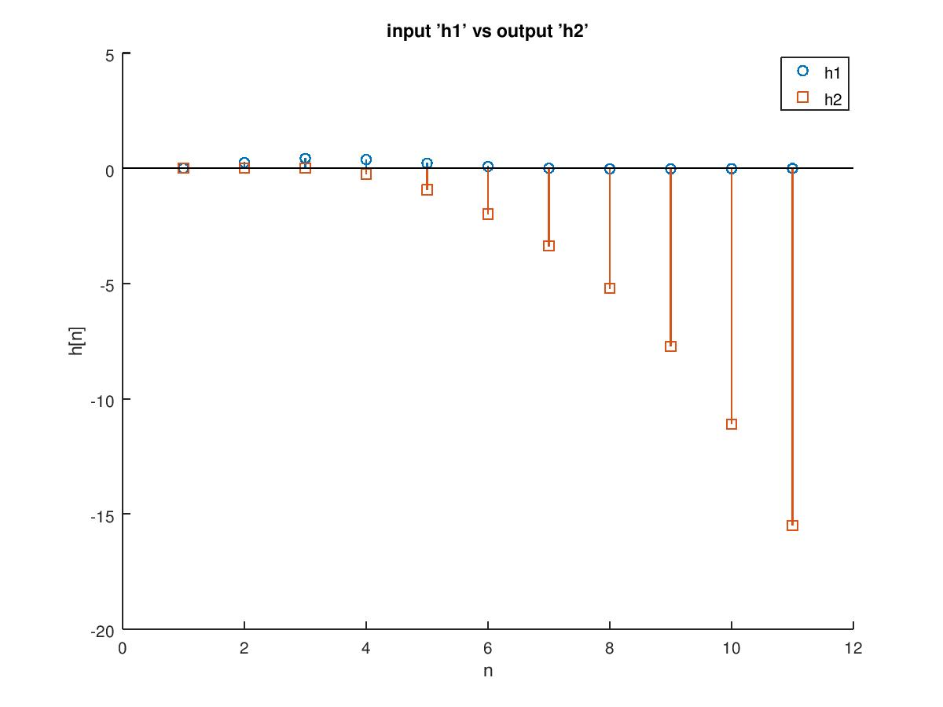
Lab3B:
Range of Convergence
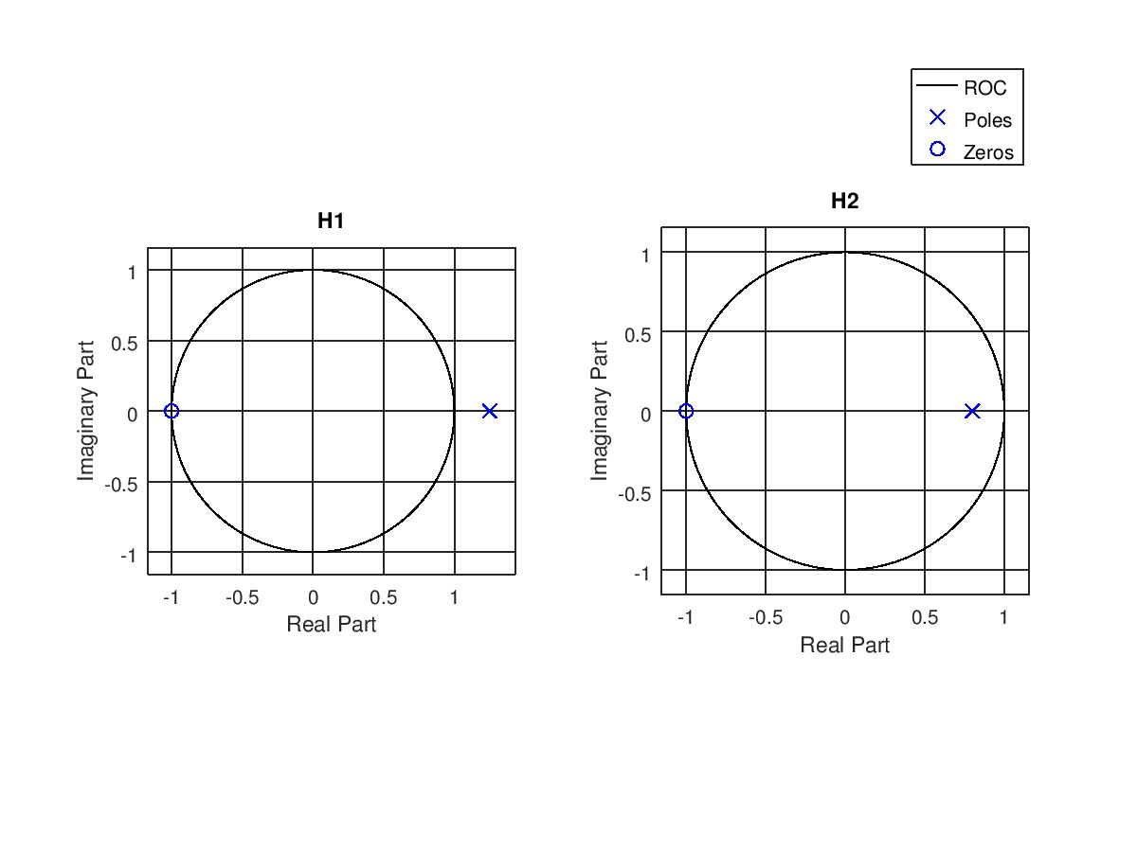

Frequency Response
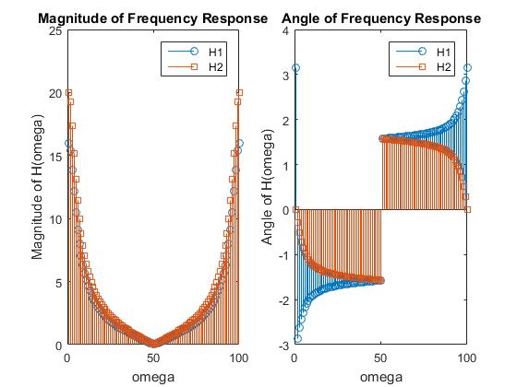
Time domain
